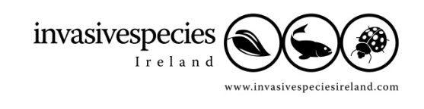
Dear Horticulturist,
You may already be aware that one of the primary threats to our native plants and habitats is from invasive species. Many of these invasive species were introduced into gardens and parks over the last couple of centuries and have subsequently escaped “over the garden wall” into our countryside. Some well known examples include giant hogweed (Heracleum mantegazzianum), Japanese knotweed (Fallopia japonica) and the floating pennywort (Hydrocotyle ranunculoides).
Invasive species are estimated to cost the European economy in excess of €12 Billion per annum. The problems caused by invasive species are steadily getting worse as movement of people and goods increase.
To help stop the spread of invasive species associated with horticultural activities, a Code of Good Practice was developed by working in partnership with the industry. This Code was published in 2008 and promoted voluntary measures aimed at reducing and limiting the spread of invasive species known to be associated with horticulture.
Since the time of producing the Code we have seen developments in Ireland, Northern Ireland and at an EU level which have a bearing on the industry and how this Code. For example, legislation in Ireland and Northern Ireland is currently under review which may prohibit the sale of some invasive species. The European Commission is expected to produce an EU wide invasive species strategy. The EU has also developed a code of conduct on horticulture and invasive alien plants. The Code developed for the horticulture trade in Ireland and Northern Ireland warrants review.
oooOOOooo
Background:
Most introductions associated with horticulture have been beneficial and have not caused either environmental or economic problems. However, the small percentages of introductions that become invasive require management. The horticultural industry has a key role to play in managing and preventing the spread of invasive species, protecting the environment and protecting your industry.
Example measures called for in the 2008 Code:
The previous Code aimed to promote an increased knowledge of invasive species and any potential impacts associated with the most damaging and costly species. The industry was encouraged to engage with end users and promote good practice in the care of plants to prevent them from becoming invasive. Industry was encouraged to promote the use of non-invasive species in gardens and public demesnes. The Code also aimed to promote adoption of measures to prevent the accidental spread of hitch-hiking pests on plants and in soil.

What the Code does not and will not do:
It is recognised that many non-native plants do not become invasive nor cause problems. Indeed, the horticulture industry would not be as successful, and the private and public gardens so beautiful and varied, in Ireland and Northern Ireland without the non-native plants that are imported and cultivated. This Code does not seek to stop trade in these plants. However, by setting out good practice for all those involved in horticulture it does seek to prevent the further spread of invasive species into our landscapes and natural habitats, where they become a danger to the environment and costly to control.
Status of the updated Code:
The Code will remain voluntary. As with the previous Code, it will aim to promote a standard of reasonable behaviour that, if followed carefully, will help ensure compliance with legislation and prevent the spread of invasive species in Ireland and Northern Ireland.
Overview of the update process:
The updated code of practice will be developed by working with the horticultural industry. A consultation process will be undertaken giving industry the opportunity to discuss the Code and raise concerns. The consultation will also aim to identify how best to embed the revised Code.
Contacts:
More information will be made available over the coming weeks and months but should you have any questions on this Code or the work of Invasive Species Ireland, you can contact us on one of the following:
- www.invasivespeciesireland.com.
- Contact John Kelly directly on john@invasivespeciesireland.com or 04890 31 6987. From Northern Ireland, please dial 02890 31 6987.
oooOOOooo
We look forward to working with you to better protect our native plants and habitats while ensuring the horticulture industry remains a thriving and vibrant part of the economies of Ireland and Northern Ireland.
Yours sincerely,

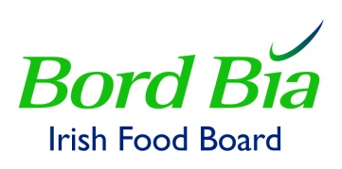
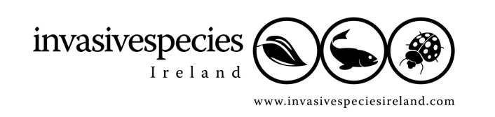
John Kelly Carol Marks

